

**MONEY MATTER : A PERSONAL FINANCE**

**MANAGEMENT APP PROJECT**

**A PROJECT REPORT**

**Submitted by :**

**ABIRENIS. – 812022104004**

**MALARAVAN – 812022104040**

**GOPINATH - 812022104026**

**KATHIRMANI – 812022104501**

**BACHELOR OF ENGINEERING**

**IN**

**COMPUTER SCIENCE AND ENGINEERING**

**M.A.M COLLEGE OF ENGINEERING AND TECHNOLOGY**

**ANNA UNIVERSITY CHENNAI :: 6200025**

**November 2024**

### **Introduction**

Managing personal finances effectively is essential in today’s fast-paced, consumer-driven world. With the increasing complexity of financial products, fluctuating economic conditions, and the rise of digital transactions, individuals often struggle to keep track of their spending, savings, and investments. Many people face challenges like overspending, inadequate savings, and lack of clear financial goals, which can hinder their financial stability and overall well-being. “Money Matters" aims to address these challenges by providing a comprehensive yet user-friendly personal finance management solution. Designed for individuals who want better control over their financial lives, this app offers tools to track expenses, set and manage budgets, and save towards personal goals. By making finance management simpler and more accessible, "Money Matters" empowers users to build better financial habits, reduce unnecessary expenses, and work towards financial freedom.The purpose of this project is to create an intuitive and secure platform that brings together essential features for budgeting, expense tracking, and goal setting. By offering insightful analytics, personalized recommendations, and real-time tracking, "Money Matters" intends to be a one-stop solution for individuals of all ages who want to improve their financial

### **Abstract**

"Money Matters" is a personal finance management app designed to help users gain control over their finances through effective budgeting, expense tracking, and goal setting. With the rise of digital transactions and the complexity of financial management, many individuals find it challenging to track spending, save efficiently, and work towards their financial objectives. This project aims to address these challenges by developing an intuitive, secure, and user-friendly application that provides essential tools for managing personal finances.The app allows users to track expenses in real time, set budgets for different spending categories, and monitor progress toward their savings goals. Additionally, it provides personalized insights into spending habits and offers reminders for bill payments and other financial obligations. "Money Matters" employs a robust system architecture, using secure data encryption and user authentication to ensure privacy and protect user data. The app’s design focuses on simplicity and accessibility, making it suitable for a wide range of users. This report outlines the project's goals, development process, key features, and technical architecture. It also discusses the challenges faced during development and the future enhancements planned to expand the app's functionality. Ultimately, "Money Matters" aims to help users develop healthier financial habits, improve savings, and achieve financial stability.

**Overview**

“Money Matters” is a comprehensive personal finance management app that helps users organize their finances, track spending, and achieve their financial goals. It is designed to address the growing need for effective financial planning tools in an increasingly digital world where individuals often struggle with managing their money efficiently. The app provides users with an all-in-one platform to monitor expenses, create budgets, and set savings targets.The [app’s key features include real-time](mailto:app’s%20key%20features%20include%20real-time) expense tracking, customizable budgets, savings goal tracking, and insightful analytics that provide a detailed view of spending patterns. It also offers notifications for bill reminders and alerts for budget limits to encourage better financial habits. To ensure data security and privacy, “Money Matters” integrates robust encryption and user authentication mechanisms. The development process Involved designing a user-friendly interface, implementing advanced data management techniques, and integrating third-party APIs for added functionality such as currency conversion and financial news. By prioritizing simplicity and accessibility, the app caters to a diverse audience, from students managing allowances to professionals looking to optimize their finances. This project focuses on empowering users with tools and insights to make informed financial decisions, reduce unnecessary expenses, and achieve long-term financial stability. This report provides a detailed account of the app’s development, functionality, and future enhancements.

**Project Scope**

**Core Features:** Describe the key features of the app, such as:

**Expense Tracking:** Track daily, weekly, and monthly expenses.

**Budgeting Tool:** Set and monitor budgets for different categories like groceries, transportation, and entertainment.

**Savings Goals:** Set and track progress toward specific savings goals.

**Financial Insights:** Offer analytics and visualizations of spending habits.

**Notifications and Reminders:** Alerts for upcoming bill payments, low balance notifications, etc.

**Additional Features:** Mention any additional functionalities, such as data encryption for security, customizable dashboards, and financial education resources.

**System Architecture**

Describe the overall structure of the app, such as a three-tier architecture (user interface, backend server, database).

**User Interface (UI):** Explain the front-end design, focusing on simplicity and ease of use.

**Backend**: Discuss the server-side logic and data handling (e.g., using REST APIs for communication).

**Database**: Explain the type of database used (e.g., SQLite for a lightweight solution or MySQL for more scalable storage).

**Technology Stack**

**Front-end:** Outline the front-end development tools and frameworks (e.g., Flutter for cross-platform development).

**Back-end:** Discuss the back-end language and framework (e.g., Node.js with Express for server logic).

**Database**: Mention the database choice (e.g., SQLite, Firebase, or MySQL).

**API Integration**: List any third-party APIs for currency conversion, financial news, or transaction history import.

**UI/UX Design**

**User Research**: Briefly discuss any research conducted to understand the target audience’s needs.

**Wireframes and Prototypes:** Provide an overview of the app’s initial wireframes and how they evolved into the final UI.

**User Flow:** Explain the user journey from registration to regular use of features, highlighting simplicity and intuitiveness.

**Key UI Components:** Describe the design of key screens like the home dashboard, expense tracker, budget creation page, and goals dashboard.

**Development Process**

**Planning**: Describe the project planning phase, including requirements gathering and initial task allocation.

**Methodology**: Explain the development methodology used (e.g., Agile or Waterfall).

**Feature Development**: Provide details on how each core feature was implemented, including the challenges and solutions.

**Testing**: Describe the testing process, including unit testing, integration testing, and user testing.

**Security and Privacy Measures**

Discuss the security features, such as:

**Data Encryption:** Encryption of sensitive data, both in transit and at rest.

**Authentication**: Secure login methods like multi-factor authentication.

**Privacy**: Measures to ensure user data privacy, complying with GDPR or other privacy standards if relevant.

**Challenges Faced**

List and explain the challenges faced during the project:

**Technical Challenges**: Issues in coding, API integration, or database management.

**Design Challenges:** Creating an intuitive UI that balances functionality and simplicity.

**Resource Constraints:** Time, budget, or manpower limitations.

Describe the solutions or workarounds implemented to address each challenge.

**Future Enhancements**

List potential improvements, such as:

**AI-driven Recommendations:** Personal finance suggestions based on user data.

**Investment Tracking:** Track and analyze investments.

**Integration with Banks:** Sync with bank accounts for automatic expense tracking.

**Collaborative Budgeting:** Enable shared budgets for families or roommates.

**SOURCE CODE**

**Package com.example.expensestracker**

**Import android.content.Context**

**Import android.content.Intent**

**Import android.os.Bundle**

**Import androidx.activity.ComponentActivity**

**Import androidx.activity.compose.setContent**

**Import androidx.compose.foundation.Image**

**Import androidx.compose.foundation.layout.\***

**Import androidx.compose.material.\***

**Import androidx.compose.runtime.\***

**Import androidx.compose.ui.Alignment**

**Import androidx.compose.ui.Modifier**

**Import androidx.compose.ui.graphics.Color**

**Import androidx.compose.ui.layout.ContentScale**

**Import androidx.compose.ui.res.painterResource**

**Import androidx.compose.ui.text.font.FontFamily**

**Import androidx.compose.ui.text.font.FontWeight**

**Import androidx.compose.ui.text.input.PasswordVisualTransformation**

**Import androidx.compose.ui.text.input.VisualTransformation**

**Import androidx.compose.ui.tooling.preview.Preview**

**Import androidx.compose.ui.unit.dp**

**Import androidx.compose.ui.unit.sp**

**Import androidx.core.content.ContextCompat**

**Import com.example.expensestracker.ui.theme.ExpensesTrackerTheme**

**Class LoginActivity : ComponentActivity() {**

**Private lateinit var databaseHelper: UserDatabaseHelper**

**Override fun onCreate(savedInstanceState: Bundle?) {**

**Super.onCreate(savedInstanceState)**

**databaseHelper = UserDatabaseHelper(this)**

**setContent {**

**ExpensesTrackerTheme {**

**// A surface container using the ‘background’ color from the theme**

**Surface(**

**Modifier = Modifier.fillMaxSize(),**

**Color = MaterialTheme.colors.background**

**) {**

**LoginScreen(this, databaseHelper)**

**}**

**}**

**}**

**}**

**}**

**@Composable**

**Fun LoginScreen(context: Context, databaseHelper: UserDatabaseHelper) {**

**Image(**

**painterResource(id = R.drawable.img_1), contentDescription = “”,**

**alpha =0.3F,**

**contentScale = ContentScale.FillHeight,**

**)**

**Var username by remember { mutableStateOf(“”) }**

**Var password by remember { mutableStateOf(“”) }**

**Var error by remember { mutableStateOf(“”) }**

**Column(**

**Modifier = Modifier.fillMaxSize(),**

**horizontalAlignment = Alignment.CenterHorizontally,**

**verticalArrangement = Arrangement.Center**

**) {**

**Text(**

**fontSize = 36.sp,**

**fontWeight = FontWeight.ExtraBold,**

**fontFamily = FontFamily.Cursive,**

**color = Color.White,**

**text = “Login”**

**)**

**Spacer(modifier = Modifier.height(10.dp))**

**TextField(**

**Value = username,**

**onValueChange = { username = it },**

**label = { Text(“Username”) },**

**modifier = Modifier.padding(10.dp)**

**.width(280.dp)**

**)**

**TextField(**

**Value = password,**

**onValueChange = { password = it },**

**label = { Text(“Password”) },**

**modifier = Modifier.padding(10.dp)**

**.width(280.dp),**

**visualTransformation = PasswordVisualTransformation()**

**)**

**If (error.isNotEmpty()) {**

**Text(**

**Text = error,**

**Color = MaterialTheme.colors.error,**

**Modifier = Modifier.padding(vertical = 16.dp)**

**)**

**}**

**Button(**

**onClick = {**

**if (username.isNotEmpty() && password.isNotEmpty()) {**

**val user = databaseHelper.getUserByUsername(username)**

**if (user != null && user.password == password) {**

**error = “Successfully log in”**

**context.startActivity(**

**Intent(**

**Context,**

**MainActivity::class.java**

**)**

**)**

**//onLoginSuccess()**

**}**

**Else {**

**Error = “Invalid username or password”**

**}**

**} else {**

**Error = “Please fill all fields”**

**}**

**},**

**Modifier = Modifier.padding(top = 16.dp)**

**) {**

**Text(text = “Login”)**

**}**

**Row {**

**TextButton(onClick = {context.startActivity(**

**Intent(**

**Context,**

**RegisterActivity::class.java**

**)**

**)}**

**)**

**{ Text(color = Color.White,text = “Sign up”) }**

**TextButton(onClick = {**

**})**

**{**

**Spacer(modifier = Modifier.width(60.dp))**

**Text(color = Color.White,text = “Forget password?”)**

**}**

**}**

**}**

**}**

**Private fun startMainPage(context: Context) {**

**Val intent = Intent(context, MainActivity::class.java)**

**ContextCompat.startActivity(context, intent, null)**

**}**

**OUTPUT :**

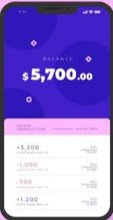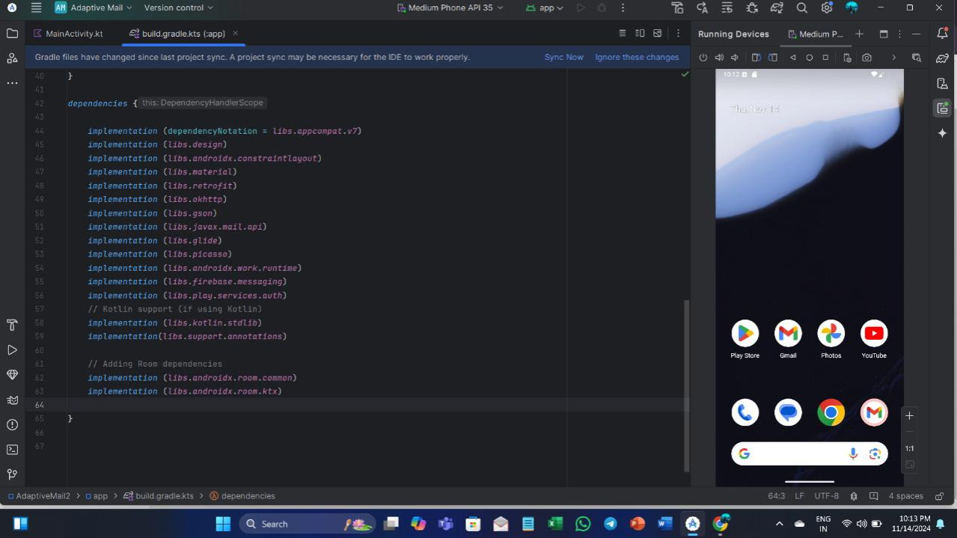

**Conclusion**

The “Money Matters” personal finance management app is a significant step toward empowering individuals to take control of their financial well-being. By offering a comprehensive platform for tracking expenses, setting budgets, and achieving savings goals, the app addresses common challenges faced in personal finance management. Its user-friendly interface, combined with robust security measures, ensures a seamless and safe experience for users of all ages.The development process highlighted the Importance of balancing functionality with simplicity to create a solution that is both effective and accessible. Despite challenges in design, implementation, and integration, the project successfully delivered an app that caters to the diverse needs of its users. Feedback from testing suggests that “Money Matters” has the potential to positively impact users’ financial habits and improve their overall financial stability.Looking ahead, the app has room for enhancement, including advanced features like AI-driven recommendations, investment tracking, and integration with banking services. These future upgrades aim to make “Money Matters” an even more comprehensive tool for personal finance management. In conclusion, “Money Matters” is not just an app but a step towards financial empowerment, providing users with the tools and insights needed to build a more secure and stable financial future.